Assignment 1
A Comparison of Gradient-Based Optimizers
Performance Analysis and Comparison of SGD and its derivatives
Malik Muhammad Abdullah Hassan - 02621070
04-6-2026

Contents
Table of Figures 1
Research Background 2
Theoretical Development 2
SGD 2
Momentum 3
Adam 3
Adagrad 4
Test Functions 4
Shubert Function 4
Beale Function 5
Programming Verification 6
Conclusion 8
Appendix 10
References 10
Program Code 11
AI Logs 11
Further Results and Visuals 19

Table of Figures
Figure 1: Shubert Function Visualization 5
Figure 2: Beale Function Visualization 5
Figure 3: Loss Curves for Shubert Function 6
Figure 4: Loss Curves for Beale Function 6
Figure 5: Optimizer paths on Shubert Function Contour 7
Figure 6: Optimizer Paths on Beale Function Contour 8
Figure 7: Optimizer Paths on Shubert Function – 3D Plot 19
Figure 8: Optimizer Paths on Beale Function - 3D Plot 20

Table 1: Shubert Function – Optimization Results 6
Table 2: Beale Function – Optimization Results 7

Research Background
For all neural networks, one of the critical components is the optimizer. In basic terms, the optimizer is the function that is used to minimize the loss. It evaluates the loss at every step and then updates the weights of the neural network, so that the performance accuracy is greater.
In mathematical terms, the optimizer seeks to minimize the gradient in such a way that the loss function hits a minimal point. The target is to hit the global minima, but as this report will explore further on, that is not always possible.
Several different optimizers have been developed and tested for a wide variety of different purposes. The most basic of these is gradient descent, which involves simply computing the gradient at each point and then trying to minimize it. Advanced methods can include improvements such as averaging the gradients, adding extra boost to the change, updating the weights based on a square difference, among others. This report will try to explore how different optimizers function by comparing four optimizers: SGD, Momentum, Adam, and Adagrad, on how well they can handle different types of test functions.

Theoretical Development
This section will aim to discuss the different optimizers and how they function, along with the loss functions that will be used to evaluate them. The optimizers were chosen to be based on SGD, to better highlight how even minor differences in method can result in completely different results. The two test functions were chosen for their unique properties: Shubert for its multiple minima, and Beale for its sharp valley, following a flat region.

SGD
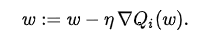
The formula above shows the basic update rule, where $ω$ is the model parameters, η is the learning rate, and $∇Q_{i}(ω)$ is the gradient of the loss. Rather than computing the gradient over the full dataset, SGD computes it using only a single sample or small mini-batch at each step. This makes each update faster to compute, but also noisy. The noise can help the optimizer avoid getting stuck in a local minimum, but it can also cause the optimizer to oscillate and not converge cleanly. Another limitation is that the same learning rate is applied to every parameter, which does not account for the fact that some parameters may need larger or smaller updates than others.

Momentum
Momentum, or SGD with Momentum, is an extension of SGD that adds a velocity term to the update. This velocity is an accumulation of past gradients, which allows the optimizer to build up speed in a consistent direction.
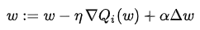
where $α$ is the momentum coefficient, which is typically set to 0.9. When the gradients are consistently pointing in the same direction, the velocity grows and the optimizer takes larger steps. When gradients change direction often, the velocity is reduced and the updates are more stable. This helps Momentum converge faster than SGD in many cases. It can still overshoot the minimum if the learning rate or momentum coefficient are set too high.

Adam
Adam, or Adaptive Moment Estimation, was introduced by Kingma and Ba (2015). It keeps track of both the first moment (the mean of the gradients) and the second moment (the mean of the squared gradients) for each parameter. This allows it to set a different effective learning rate for each parameter based on how much it has been updated in the past. The update equations are:
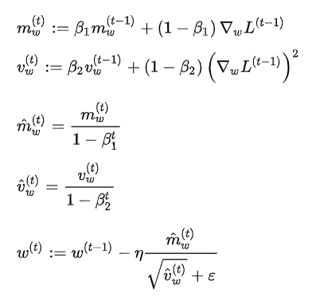
The default values are $β₁ = 0.9$, $β₂ = 0.999$, and $ε = 10⁻⁸$. The bias-corrected terms $m̂(t)$ and $v̂(t)$ are needed because $m(t)$ and $v(t)$ are both initialized to zero, which would cause the estimates to be too small early in training. Because the learning rate for each parameter is scaled by its past gradients, parameters that receive large gradients get a smaller step size, and parameters that receive small gradients get a larger one. This means Adam tends to converge faster than SGD and requires less manual tuning of the learning rate.

Adagrad
Adagrad, or Adaptive Gradient, was introduced by Duchi, Hazan, and Singer (2011). It adapts the learning rate individually for each parameter by accumulating the sum of its squared past gradients. All operations are applied element-wise, meaning each parameter has its own independent accumulator. The update equations are:
$$g(t) = ∇L(ω)$$
$$G(t) = G(t-1) + g(t) ⊙ g(t)$$
$$ω := ω - \frac{η}{\sqrt{G(t) + ε}} ⊙ g(t)$$
where $g(t)$ is the gradient at step $t$, $G(t)$ is the element-wise cumulative sum of squared gradients, $⊙$ denotes element-wise multiplication, and $ε$ is a small constant to avoid division by zero. Because each parameter has its own $G(t)$, parameters that have received large gradients in the past will have a large $G(t)$ and therefore a smaller effective learning rate. Parameters that have received small gradients will have a small $G(t)$ and a larger effective learning rate. This makes Adagrad well suited to sparse data, where some parameters are updated rarely and benefit from a larger step size when they are. The main limitation is that $G(t)$ only ever grows, so the learning rate keeps shrinking throughout training and can eventually stop progress altogether.

Test Functions
Test functions are a useful way to evaluate the characteristics of any optimization algorithm. Test functions can be created to have any set properties, such as having multiple minima, or having a complex curvature. These properties can help evaluate the effectiveness of optimizers while tackling complex tasks. For the purposes of this paper, functions with known global minima and properties were chosen as detailed below:

Shubert Function
The Shubert function has several local minima and many global minima. This can be used to evaluate the ability of an optimizer to select the proper minima from several options. The mathematical and graphical representation is as follows:
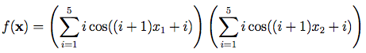
The function is usually evaluated on the square x_{i} ∈ [-10, 10], for all $i$ = 1, 2, although this may be restricted to the square x_{i} ∈ [-5.12, 5.12], for all $i$ = 1, 2.
Global Minimum:
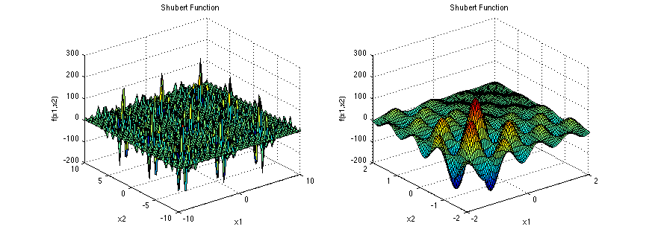
Figure 1: Shubert Function Visualization
The second plot shows the function on a smaller input domain, to allow for easier viewing.

Beale Function
The Beale function is multimodal, with sharp peaks at the corners of the input domain.
The function is usually evaluated on the square x_{i} ∈ [-4.5, 4.5], for all i = 1, 2.
Global Minimum:
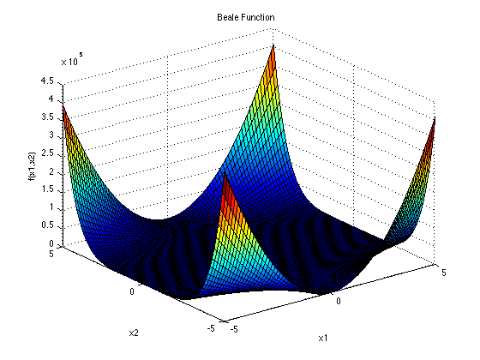
Figure 2: Beale Function Visualization

Programming Verification
To compare the optimizers, a program was created that would run each of the optimizers on the two loss functions, and compare their results for accuracy against each other. The code is attached in the appendix for reference. The discussion for the results is incorporated into the next section.
The optimizers were all tested with the same starting points for consistency. To ensure best performance for each optimizer, they were all tested with different learning rates, and the best among them was chosen to compare. Each optimizer was trained for 1000 steps to allow for full evaluation. The final results were visually compared on contour plots to get a complete picture of how each worked.
To begin with the results, first we find the loss for each optimizer on each learning rate as discussed. It can be seen that all optimizers were able to reach a desired loss state for the Shubert function albeit at different learning rates.
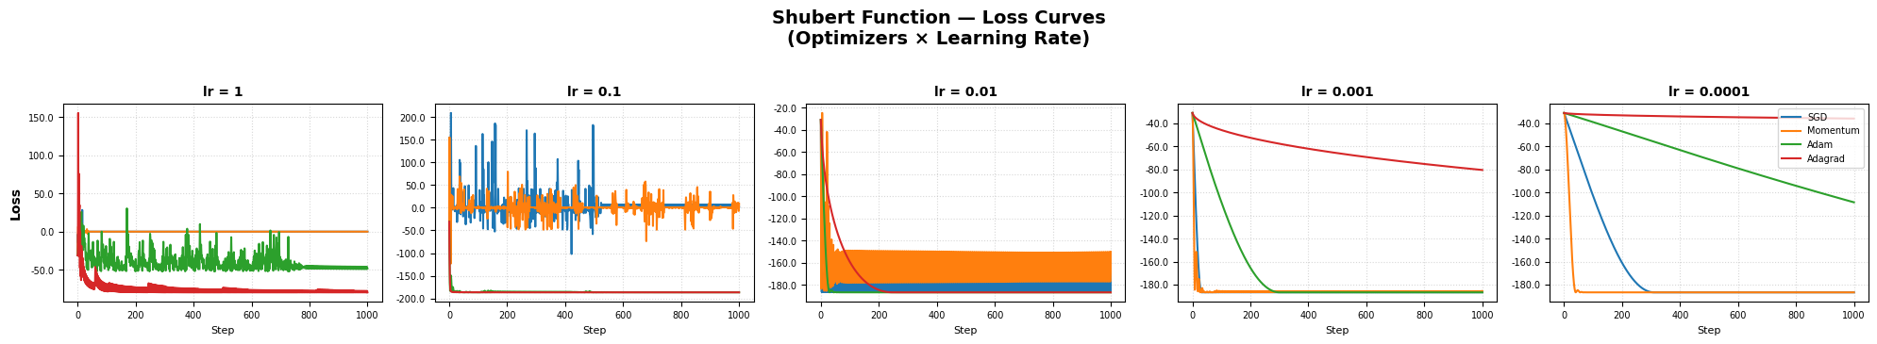
Figure 3: Loss Curves for Shubert Function
However, when we turn towards the Beale function, we note that only Adagrad and Adam were able to reach the low loss state.
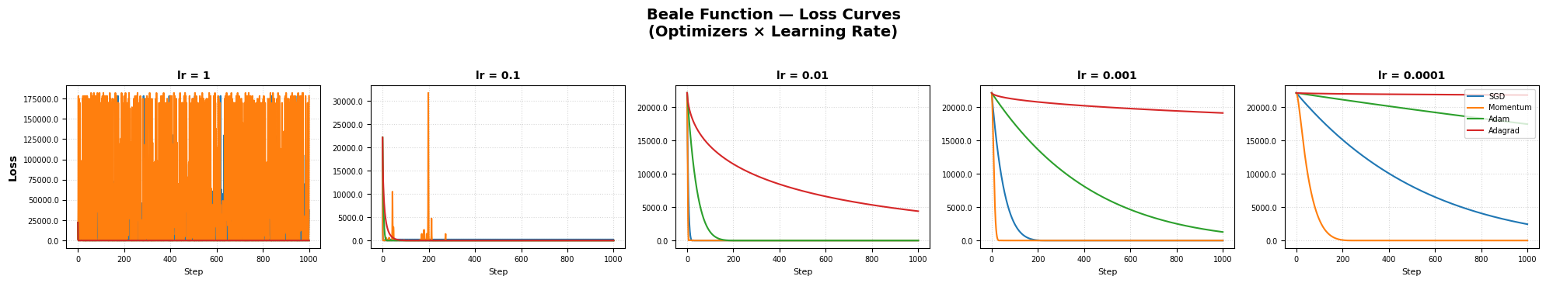
Figure 4: Loss Curves for Beale Function
Next, the tables with the optimization results:
Optimizer | Convergence Step | Learning Rate | Found Global Min
SGD | 282 | 0.0001 | Found
Momentum | 38 | 0.0001 | Found
Adam | 271 | 0.001 | Found
Adagrad | 204 | 0.01 | Found
Table 1: Shubert Function – Optimization Results

Optimizer | Convergence Step | Learning Rate | Found Global Min
SGD | 427 | 0.001 | Missed
Momentum | 202 | 0.01 | Found
Adam | 175 | 1 | Found
Adagrad | 745 | 1 | Missed
Table 2: Beale Function – Optimization Results
The real crux of the results, and the basis of our discussion can be seen in Figure 5 and Figure 6. The 3D contour plots can be found in the appendix.
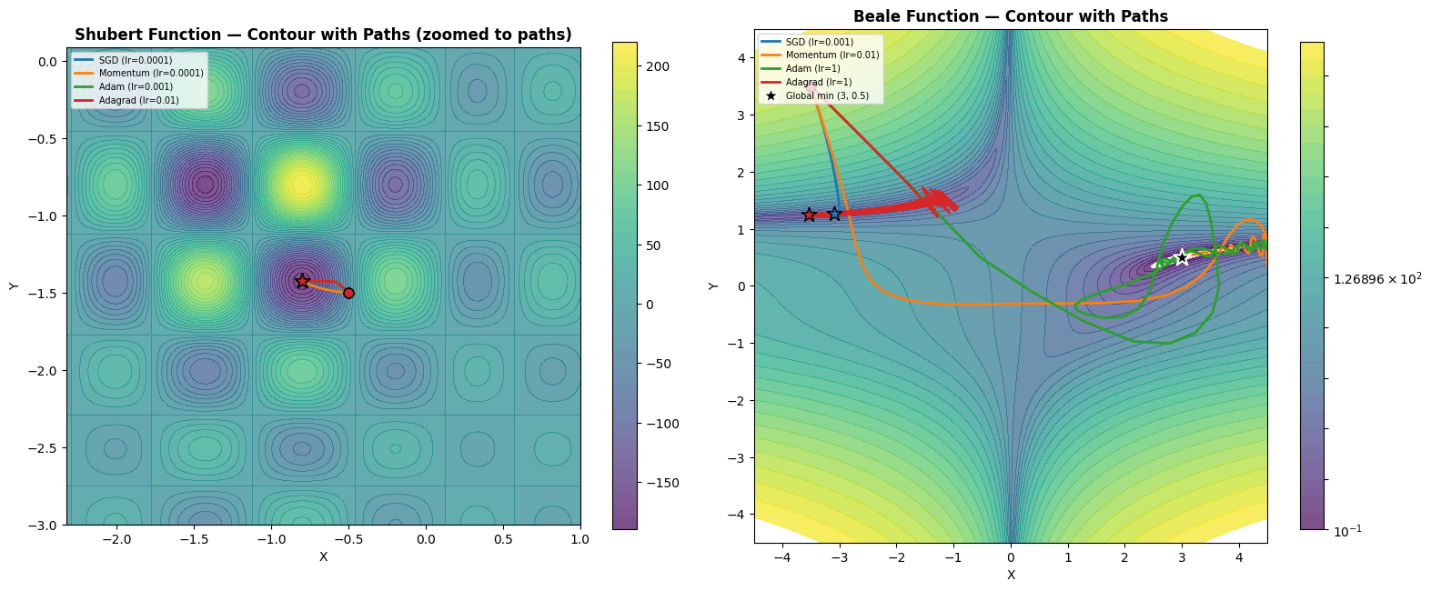
Figure 5: Optimizer Paths on Shubert Function Contour


Figure 6: Optimizer Paths on Beale Function Contour
It can be clearly seen that all optimizers converged in the case of the Shubert function, with a difference in the speed of convergence, with Momentum being the fastest. Each optimizer was able to overcome the different minima problem and reach the proper global minima.
In the Beale function example, however, we see that SGD and Adagrad fail to converge, getting stuck in the steep valley created by the function.

Conclusion
Through the study we have now evaluated the behavior of the different optimizers on both test functions. We see that with a good starting point, optimized learning rate and enough steps, the issue of the Shubert function was overcome. However, it is still worth noting that this was dependent on the hyperparameters in each optimizers’ case. A small difference in the setup would result in failure, which is a topic to explore on its own.
The more interesting case to discuss is that of the Beale function, where only Momentum and Adam could succeed. To understand why, it serves to revisit both the test function and how each optimizer works. The Beale function has many shallow regions with steep walls that can confuse optimizers as to the best direction. For SGD, which is a simple gradient based mechanism, it found the first low point, but could not get out of that valley. Adagrad has the capability of learning from its past gradients, but it also fails to break free of the first obstacle. This can be attributed to the fact that even though it is accumulating the gradient, it is doing so in squares, which lead to the algorithm becoming ‘bloated’ and slowing down, getting stuck in the same valley. In contrast, both Adam and Momentum have one key factor working for them: velocity. Momentum utilizes the sum of its past gradients, which allow it to break free of the valley, but do not build up so much that the algorithm slows down. It takes big enough steps to overcome the difference in gradient created by the shallow region. Adam follows the same concept as Adagrad and Momentum, but it introduces a powerful mechanism: decay. Decaying the past unneeded gradients allow it to keep rolling forwards, and even though it takes a circular route, the flexibility of both moments allows it to find the final global minimum.
Gradient descent methods are a powerful study in how just using gradients as a simple tool can allow models to learn even the most difficult functions. This report discusses a few specific cases to draw a comparison between their capabilities. In recent work, the preferred gradient optimizer has been Adam, due to its double-headed capability as we discussed previously. Moving forward, we can be hopeful that further research and development will give us even better and more sophisticated models.

Appendix

References
- Surjanovic, S. & Bingham, D. (2013). Virtual Library of Simulation Experiments: Test Functions and Datasets. Retrieved April 3, 2026, from http://www.sfu.ca/~ssurjano.
- Rosenblatt, F. (1958). The perceptron: A probabilistic model for information storage and organization in the brain. Psychological Review, 65(6), 386–408. https://doi.org/10.1037/h0042519
- Rumelhart, D. E., Hinton, G. E., & Williams, R. J. (1986). Learning representations by back-propagating errors. Nature, 323(6088), 533–536. https://doi.org/10.1038/323533a0
- Polyak, B. T., & Juditsky, A. B. (1992). Acceleration of Stochastic Approximation by Averaging. SIAM Journal on Control and Optimization, 30(4), 838–855. https://doi.org/10.1137/0330046
- Kingma, D. P., & Ba, J. L. (2015). Adam: A method for stochastic optimization. In Proceedings of the 3rd International Conference on Learning Representations (ICLR). https://arxiv.org/pdf/1412.6980
- Duchi, J., Hazan, E., & Singer, Y. (2011). Adaptive subgradient methods for online learning and stochastic optimization. Journal of Machine Learning Research, 12, 2121–2159. https://jmlr.org/papers/volume12/duchi11a/duchi11a.pdf

Program Code
import torch
import torch.nn as nn
import torch.optim as optim
import matplotlib.pyplot as plt
import matplotlib.ticker as ticker
import numpy as np
import pandas as pd
from mpl_toolkits.mplot3d import Axes3D
# ── Test Function Definitions (pure PyTorch for autograd) ─────────────────────

def shubert(x, y):
"""Shubert function. Domain: [-10, 10]^2. 18 global minima ≈ -186.7309."""
sum_x = sum(i * torch.cos((i + 1) * x + i) for i in range(1, 6))
sum_y = sum(i * torch.cos((i + 1) * y + i) for i in range(1, 6))
return sum_x * sum_y

def beale(x, y):
"""Beale function. Domain: [-4.5, 4.5]^2. Global minimum at (3, 0.5) = 0."""
t1 = (1.5 - x + x * y) ** 2
t2 = (2.25 - x + x * y ** 2) ** 2
t3 = (2.625 - x + x * y ** 3) ** 2
return t1 + t2 + t3

# NumPy versions for surface mesh computation (no gradients needed)
def shubert_np(x, y):
sum_x = sum(i * np.cos((i + 1) * x + i) for i in range(1, 6))
sum_y = sum(i * np.cos((i + 1) * y + i) for i in range(1, 6))
return sum_x * sum_y

def beale_np(x, y):
return (1.5 - x + x*y)**2 + (2.25 - x + x*y**2)**2 + (2.625 - x + x*y**3)**2
# ── Experiment Parameters ─────────────────────────────────────────────────────
STEPS = 1000
OPTIMIZERS = ['SGD', 'Momentum', 'Adam', 'Adagrad']
LRS = [1, 0.1, 0.01, 0.001, 0.0001]
SEED = 42

# Starting points (same for all optimizers, per function)
# Shubert: (-0.5, -1.5) is near a basin leading to the global minimum ≈ -186.73
# Beale: (-3.5, 3.5) is a challenging far-corner start
START_POINTS = {
'Shubert': (-0.5, -1.5),
'Beale': (-3.5, 3.5),
}

# Function registry
FUNCTIONS = {
'Shubert': {'func': shubert, 'func_np': shubert_np, 'domain': (-10, 10)},
'Beale': {'func': beale, 'func_np': beale_np, 'domain': (-4.5, 4.5)},
}

COLORS = {
'SGD': '#1f77b4',
'Momentum': '#ff7f0e',
'Adam': '#2ca02c',
'Adagrad': '#d62728',
}

def make_optimizer(name, params, lr):
"""Return an optimizer instance by name."""
if name == 'SGD': return optim.SGD(params, lr=lr)
elif name == 'Momentum': return optim.SGD(params, lr=lr, momentum=0.9)
elif name == 'Adam': return optim.Adam(params, lr=lr)
elif name == 'Adagrad': return optim.Adagrad(params, lr=lr)
else: raise ValueError(f'Unknown optimizer: {name}')
# ── Run all combinations ──────────────────────────────────────────────────────
results = {} # results[(func_name, opt_name, lr)] = {'path_x', 'path_y', 'path_z'}

for func_name, finfo in FUNCTIONS.items():
func = finfo['func']
lo, hi = finfo['domain']
x0, y0 = START_POINTS[func_name]

for opt_name in OPTIMIZERS:
for lr in LRS:
torch.manual_seed(SEED)

x = nn.Parameter(torch.tensor(x0))
y = nn.Parameter(torch.tensor(y0))
optimizer = make_optimizer(opt_name, [x, y], lr)

path_x, path_y, path_z = [x0], [y0], []

# Record initial loss
with torch.no_grad():
init_loss = func(x, y).item()
path_z.append(init_loss)

for step in range(STEPS):
loss = func(x, y)

# NaN / Inf guard
if torch.isnan(loss) or torch.isinf(loss):
last_x = path_x[-1]
last_y = path_y[-1]
last_z = path_z[-1]
remaining = STEPS - step
path_x.extend([last_x] * remaining)
path_y.extend([last_y] * remaining)
path_z.extend([last_z] * remaining)
break

optimizer.zero_grad()
loss.backward()
nn.utils.clip_grad_norm_([x, y], max_norm=10.0)
optimizer.step()

# Clamp to domain bounds
x.data.clamp_(lo, hi)
y.data.clamp_(lo, hi)

path_x.append(x.item())
path_y.append(y.item())
path_z.append(func(x, y).item())

results[(func_name, opt_name, lr)] = {
'path_x': path_x,
'path_y': path_y,
'path_z': path_z,
}
final = path_z[-1]
print(f'{func_name:10s} {opt_name:10s} lr={lr:.4f} → final loss: {final:.4f}')

print('\nAll combinations finished.')
# ── Loss Curves: one figure per function ──────────────────────────────────────
steps_axis = np.arange(STEPS + 1)

for func_name in FUNCTIONS:
n_lr = len(LRS)
fig, axes = plt.subplots(1, n_lr, figsize=(4 * n_lr, 3.5), sharey=False)
fig.suptitle(f'{func_name} Function — Loss Curves\n(Optimizers × Learning Rate)',
fontsize=14, fontweight='bold', y=1.03)

for c, lr in enumerate(LRS):
ax = axes[c]
for opt_name in OPTIMIZERS:
losses = results[(func_name, opt_name, lr)]['path_z']
ax.plot(steps_axis, losses, linewidth=1.5,
color=COLORS[opt_name], label=opt_name)

ax.set_title(f'lr = {lr}', fontsize=10, fontweight='bold')
ax.set_xlabel('Step', fontsize=8)
if c == 0:
ax.set_ylabel('Loss', fontsize=10, fontweight='bold')
ax.tick_params(labelsize=7)
ax.yaxis.set_major_formatter(ticker.FormatStrFormatter('%.1f'))
ax.grid(True, linestyle=':', alpha=0.5)
if c == n_lr - 1:
ax.legend(fontsize=7, loc='upper right')

plt.tight_layout()
plt.savefig(f'{func_name.lower()}_loss_curves.png', dpi=150, bbox_inches='tight')
plt.show()
print(f'Saved {func_name.lower()}_loss_curves.png')
# ── Select best learning rate per optimizer (lowest final loss) ────────────────
best_lr = {}

for func_name in FUNCTIONS:
print(f'\n{func_name} — Best learning rate per optimizer:')
for opt_name in OPTIMIZERS:
best = min(LRS, key=lambda lr: results[(func_name, opt_name, lr)]['path_z'][-1])
final = results[(func_name, opt_name, best)]['path_z'][-1]
best_lr[(func_name, opt_name)] = best
print(f' {opt_name:10s} lr={best:.4f} (final loss: {final:.4f})')

# ── 3D Surface Plot — Shubert Function ────────────────────────────────────────
func_name = 'Shubert'
lo, hi = FUNCTIONS[func_name]['domain']
func_np = FUNCTIONS[func_name]['func_np']

grid = np.linspace(lo, hi, 200)
X_mesh, Y_mesh = np.meshgrid(grid, grid)
Z_mesh = func_np(X_mesh, Y_mesh)

fig = plt.figure(figsize=(12, 8))
ax = fig.add_subplot(111, projection='3d')
ax.plot_surface(X_mesh, Y_mesh, Z_mesh, cmap='viridis', alpha=0.5,
edgecolor='none', rstride=4, cstride=4)

for opt_name in OPTIMIZERS:
lr = best_lr[(func_name, opt_name)]
r = results[(func_name, opt_name, lr)]
xs, ys, zs = r['path_x'], r['path_y'], r['path_z']
ax.plot3D(xs, ys, zs, color=COLORS[opt_name], linewidth=2,
label=f'{opt_name} (lr={lr})', zorder=5)
ax.scatter(xs[0], ys[0], zs[0], color=COLORS[opt_name],
marker='o', s=60, edgecolors='black', zorder=6)
ax.scatter(xs[-1], ys[-1], zs[-1], color=COLORS[opt_name],
marker='*', s=120, edgecolors='black', zorder=6)

ax.set_xlabel('X')
ax.set_ylabel('Y')
ax.set_zlabel('f(x, y)')
ax.set_title(f'{func_name} Function — Optimizer Paths (best LR each)',
fontsize=13, fontweight='bold')
ax.legend(loc='upper left', fontsize=8)
ax.view_init(elev=35, azim=-60)
plt.tight_layout()
plt.savefig('shubert_3d_paths.png', dpi=150, bbox_inches='tight')
plt.show()
print('Saved shubert_3d_paths.png')
# ── 3D Surface Plot — Beale Function ──────────────────────────────────────────
func_name = 'Beale'
lo, hi = FUNCTIONS[func_name]['domain']
func_np = FUNCTIONS[func_name]['func_np']

grid = np.linspace(lo, hi, 200)
X_mesh, Y_mesh = np.meshgrid(grid, grid)
Z_mesh = beale_np(X_mesh, Y_mesh)
# Clip extreme values for better visualization
Z_mesh = np.clip(Z_mesh, None, 1000)

fig = plt.figure(figsize=(12, 8))
ax = fig.add_subplot(111, projection='3d')
ax.plot_surface(X_mesh, Y_mesh, Z_mesh, cmap='viridis', alpha=0.5,
edgecolor='none', rstride=4, cstride=4)

for opt_name in OPTIMIZERS:
lr = best_lr[(func_name, opt_name)]
r = results[(func_name, opt_name, lr)]
xs, ys, zs = r['path_x'], r['path_y'], r['path_z']
# Clip path z values to match surface
zs_clipped = [min(z, 1000) for z in zs]
ax.plot3D(xs, ys, zs_clipped, color=COLORS[opt_name], linewidth=2,
label=f'{opt_name} (lr={lr})', zorder=5)
ax.scatter(xs[0], ys[0], zs_clipped[0], color=COLORS[opt_name],
marker='o', s=60, edgecolors='black', zorder=6)
ax.scatter(xs[-1], ys[-1], zs_clipped[-1], color=COLORS[opt_name],
marker='*', s=120, edgecolors='black', zorder=6)

# Mark the known global minimum
ax.scatter(3, 0.5, 0, color='black', marker='*', s=200,
edgecolors='white', linewidths=1.5, zorder=7, label='Global min (3, 0.5)')

ax.set_xlabel('X')
ax.set_ylabel('Y')
ax.set_zlabel('f(x, y)')
ax.set_title(f'{func_name} Function — Optimizer Paths (best LR each)',
fontsize=13, fontweight='bold')
ax.legend(loc='upper left', fontsize=8)
ax.view_init(elev=35, azim=-60)
plt.tight_layout()
plt.savefig('beale_3d_paths.png', dpi=150, bbox_inches='tight')
plt.show()
print('Saved beale_3d_paths.png')

# ── 2D Contour Plots — Shubert (zoomed) & Beale side by side ──────────────────
fig, axes = plt.subplots(1, 2, figsize=(16, 7))

for idx, func_name in enumerate(FUNCTIONS):
ax = axes[idx]
lo, hi = FUNCTIONS[func_name]['domain']
func_np_fn = FUNCTIONS[func_name]['func_np']

# ── Zoom the Shubert plot around the optimizer paths ──────────────
if func_name == 'Shubert':
all_xs, all_ys = [], []
for opt_name in OPTIMIZERS:
lr = best_lr[(func_name, opt_name)]
r = results[(func_name, opt_name, lr)]
all_xs.extend(r['path_x'])
all_ys.extend(r['path_y'])
pad = 1.5 # padding around the path extent
x_lo = max(lo, min(all_xs) - pad)
x_hi = min(hi, max(all_xs) + pad)
y_lo = max(lo, min(all_ys) - pad)
y_hi = min(hi, max(all_ys) + pad)
else:
x_lo, x_hi = lo, hi
y_lo, y_hi = lo, hi

grid_x = np.linspace(x_lo, x_hi, 300)
grid_y = np.linspace(y_lo, y_hi, 300)
X_m, Y_m = np.meshgrid(grid_x, grid_y)
Z_m = func_np_fn(X_m, Y_m)

# Use log-scaled contours for Beale (large range)
if func_name == 'Beale':
levels = np.logspace(-1, 5, 30)
from matplotlib.colors import LogNorm
cf = ax.contourf(X_m, Y_m, Z_m, levels=levels, cmap='viridis',
alpha=0.7, norm=LogNorm())
else:
levels = 40
cf = ax.contourf(X_m, Y_m, Z_m, levels=levels, cmap='viridis', alpha=0.7)

plt.colorbar(cf, ax=ax, shrink=0.8)

for opt_name in OPTIMIZERS:
lr = best_lr[(func_name, opt_name)]
r = results[(func_name, opt_name, lr)]
xs, ys = r['path_x'], r['path_y']
ax.plot(xs, ys, color=COLORS[opt_name], linewidth=2,
label=f'{opt_name} (lr={lr})', zorder=4)
ax.scatter(xs[0], ys[0], color=COLORS[opt_name],
marker='o', s=60, edgecolors='black', zorder=5)
ax.scatter(xs[-1], ys[-1], color=COLORS[opt_name],
marker='*', s=150, edgecolors='black', zorder=5)

if func_name == 'Beale':
ax.scatter(3, 0.5, color='black', marker='*', s=200,
edgecolors='white', linewidths=1.5, zorder=6,
label='Global min (3, 0.5)')

ax.set_xlim(x_lo, x_hi)
ax.set_ylim(y_lo, y_hi)
ax.set_xlabel('X', fontsize=10)
ax.set_ylabel('Y', fontsize=10)
title_suffix = ' (zoomed to paths)' if func_name == 'Shubert' else ''
ax.set_title(f'{func_name} Function — Contour with Paths{title_suffix}',
fontsize=12, fontweight='bold')
ax.legend(fontsize=7, loc='upper left')
ax.set_aspect('equal')

plt.tight_layout()
plt.savefig('contour_paths.png', dpi=150, bbox_inches='tight')
plt.show()
print('Saved contour_paths.png')

# ── Summary tables: final loss for every combination ──────────────────────────
for func_name in FUNCTIONS:
data = {}
for opt_name in OPTIMIZERS:
data[opt_name] = {
f'lr={lr}': round(results[(func_name, opt_name, lr)]['path_z'][-1], 4)
for lr in LRS
}

df = pd.DataFrame(data).T
df.index.name = 'Optimizer'
df.columns.name = 'Learning Rate'

styled = (df.style
.highlight_min(axis=0, props='background-color: #c6efce; color: #276221;')
.highlight_max(axis=0, props='background-color: #ffc7ce; color: #9c0006;')
.format('{:.4f}')
.set_caption(f'{func_name} — Final Loss after {STEPS} steps (green = best, red = worst per LR)')
)
display(styled)

AI Logs
The following screenshots show the prompts used during the writing of this paper. The complete response has been cut for brevity.

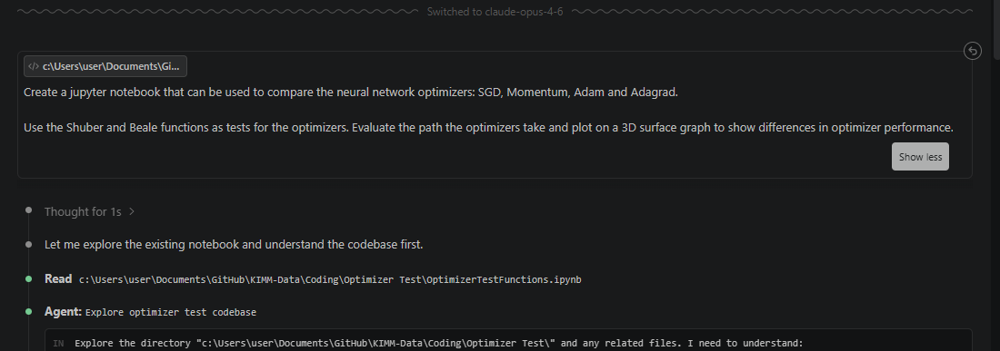


Further Results and Visuals
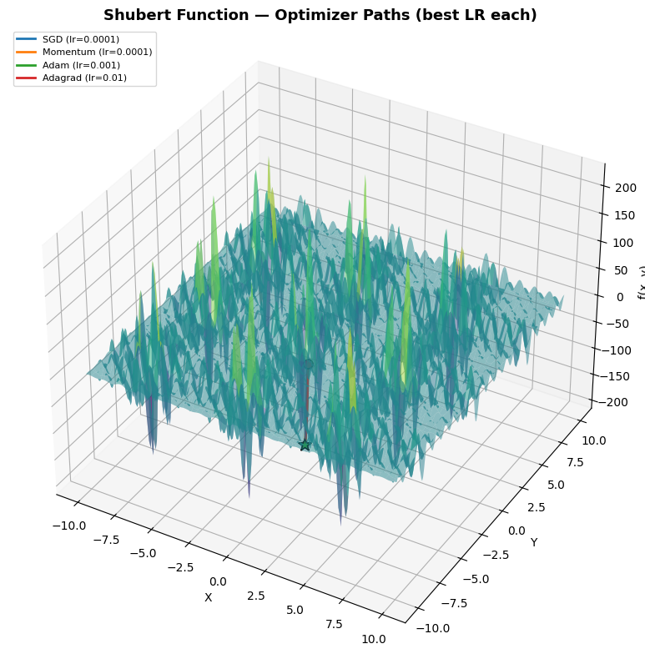
Figure 7: Optimizer Paths on Shubert Function - 3D Plot
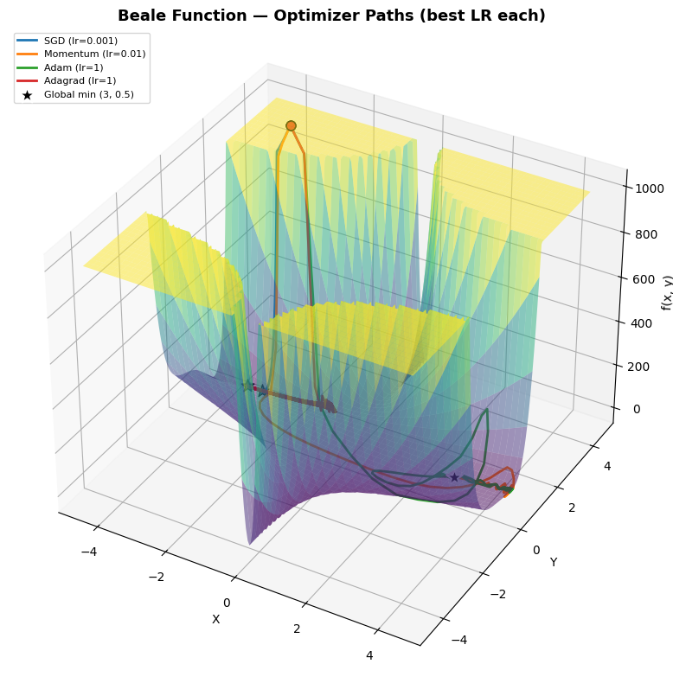
Figure 8: Optimizer Paths on Beale Function - 3D Plot

